**CloudStack**

Introduction

* Apache CloudStack is open source software designed to deploy and manage large networks of virtual machines, as a highly available, highly scalable Infrastructure as a Service (IaaS) cloud computing platform.
* CloudStack is used by a number of service providers to offer public cloud services, and by many companies to provide an on-premises (private) cloud offering, or as part of a hybrid cloud solution.
* CloudStack is a turnkey solution that includes the entire "stack" of features most organizations want with an IaaS cloud: compute orchestration, Network-as-a-Service, user and account management, a full and open native API, resource accounting, and a first-class User Interface (UI).
* CloudStack currently supports the most popular hypervisors: VMware, KVM, XenServer, Xen Cloud Platform (XCP) and Hyper-V.
* Users can manage their cloud with an easy to use Web interface, command line tools, and/or a full-featured RESTful API.

**About cloud stack**

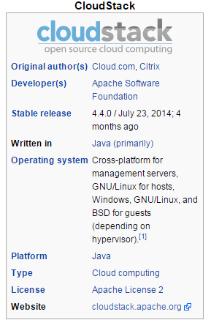

Key Features

* Built-in high-availability for hosts and VMs
* AJAX web GUI for management
* AWS API compatibility
* Hypervisor agnostic
* Snapshot management
* Usage metering
* Network management (VLAN's, security groups)
* Virtual routers, firewalls, load balancers
* Multi-role support

Why cloudstack?

* **Simple to implement, yet massively scalable.** CloudStack was the easiest of the options that we tested to get up and running, yet has been proven to scale to at least 40,000 physical hosts under management. That’s a powerful combination: simplicity and scalability.
* **Flexibility to cope with demanding requirements.** CloudStack’s design also provides significant flexibility to support the continuum of workload styles, as well as to easily integrate non-cloud-based applications with environments running in the cloud. Supporting heterogeneous architectures is critical for our customers.
* **Ability to contribute to the solution going forward.** SunGard AS has teams working on the project, enabling us to have direct input into the future direction of the product based on both our customers’ feedback and our operational experience.